

**Project Initialization and Planning Phase**

|  |  |
| --- | --- |
| Date | 20 Sep 2024 |
| Team ID | 724803 |
| Project Name | Railway Sentry: Detecting Workers on Railway Tracks using YOLO V9 |
| Maximum Marks | 3 Marks |

**Define Problem Statements (Customer Problem Statement Template):**

Railway maintenance and construction workers often perform tasks on or near active railway tracks, exposing them to the risk of oncoming trains and potential accidents. Ensuring worker safety is paramount but challenging with traditional monitoring systems that rely heavily on human surveillance, which can be prone to errors and delays. Railway Sentry aims to develop an advanced, real-time AI-based detection system that leverages YOLO V9 (You Only Look Once, Version 9) to automatically identify and track the presence of workers on railway tracks.

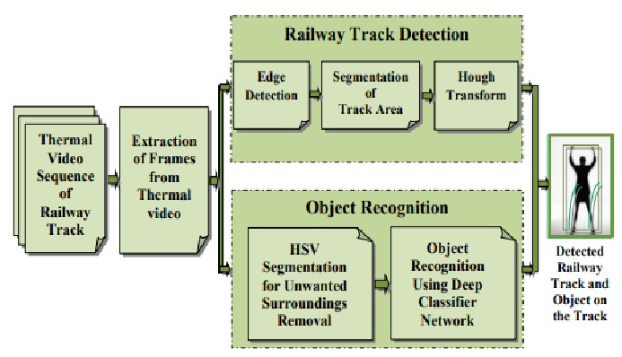

**Example:**

|  |  |  |  |  |  |
| --- | --- | --- | --- | --- | --- |
| **Problem Statement (PS)** | **I am (Customer)** | **I’m trying**  **to** | **But** | **Because** | **Which makes me feel** |
| PS-1 | I want to know whether workers are present on railway track or not | Save workers on railway track when train is about to come on the track | I  couldn’t  find where and how many  are their | Need to save workers lives | Worried |



